**HW6 CSCD320**

**This homework requires coding.**

**To turn in: please wrap up all your java source files into a zip file, then** turn in the single zip file on the **EWU Canvas** by going to CSCD320-01 course page on Canvas, then clicking Assignments🡪HW6->submit. Please name your zip file with your last name, followed by the first initial of your first name, followed by hw6. For example, if you are John Smith, name you file as smithjhw6.zip

**Specifics**

**Give an input weighted and undirected graph as shown in the diagram below, with the weight being labeled on each edge.**

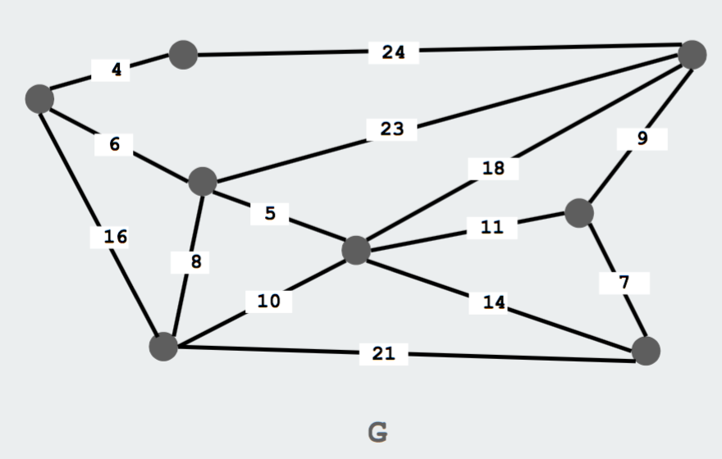

1. Please implement the **Adjacency List** OR **the Adjacency Matrix** representation to construct the graph **G** above in the main memory of your computer. You can **optionally** verify your graph construction by printing out all edges on the standard output.
2. Please implement the **BFS** algorithm to perform Breadth-first search for an undirected graph.
3. Please invoke the method of your BFS algorithm implementation on the input graph G above starting with vertex 0.
4. When running your program, please print out on the **standard output** explicitly the sequence of vertices that BFS traversal produces in the input graph. Please follow the output format shown in the below.

***The result of the BFS traversal starting from vertex 0 is:***

***0🡪1🡪2🡪3🡪7🡪5🡪4🡪6***

1. Please organize your source code so that I can compile **all** your source files in **one** folder using command, **javac *.java**, and run your program using command on command line, **java Tester.**
2. **You can have your own design for any details that have NOT been specified in this document.**